**LABSHEET-3**

**Mapreduce WordCount Java Program**

Name : Anuvind M P

Roll no : AM.EN.U4AIE22010

**INPUT 1 :**

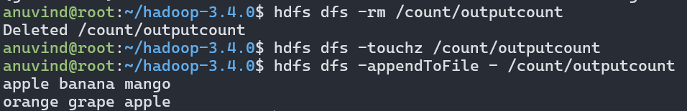

**OUTPUT :**

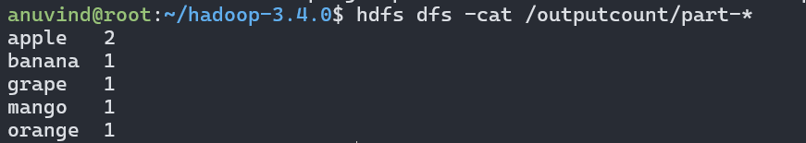

--------------------------------------------------------------------------------------------------------------------------------------

**INPUT 2 :**

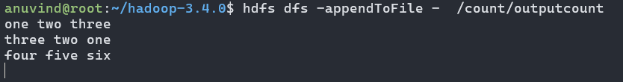

**Output :**  
